FAC is seeking providers of digital custody services for investors in digital fund assets traded on its new distributed ledger-based platform for mutual funds servicing. Fund assets traded on the FAC platform are expected to exceed $100bn in five years, making this a highly attractive ecosystem for digital custody service providers.

This opportunity would interest existing providers of conventional asset custody looking to extend their presence in the servicing of new digital asset classes or a new market entrant with a solution that meet regulatory standards.

FAC is a private, permissioned distributed ledger network built on the R3 Corda Enterprise platform which supports trading and settlement of mutual funds shares. On the FAC network both cash and fund assets are tokenised and transaction finality is achieved on ledger by atomic settlement (essentially bilateral synchronised DvP).

Institutional investors and distributors will operate nodes on the network which will allow them to trade with a range of funds from different fund managers. To maintain compliance with the relevant regulations, investors will need access to custody services for these assets.

Investors hold cash and fund assets on-ledger and require a digital custody service to protect these assets from theft and fraud. The digital custodian is independent of the FAC network and provides a service direct to the investors.

The emerging regulatory interpretation of custody in a digital context centres around the safe-keeping of the cryptographic keys (the ‘private’ keys) used by the investor to sign transactions on the distributed ledger. The digital custodian protects the keys while not in use, presents them in a secure and timely process when they are required for transaction signature, and takes them back into safe-keeping post-transaction. A digital custodian should be a regulated company of high trust and reputation, with state-of-the-art technical capabilities in security and encryption.

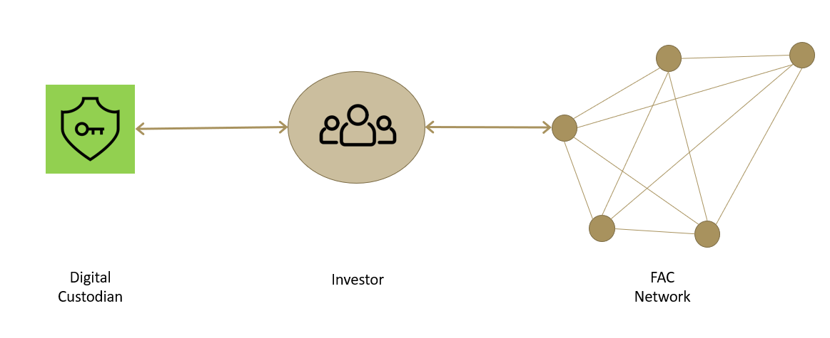

**Key Requirements**

* A UK / EU regulated entity in respect to custody services;
* A willingness to become regulated for the provision of digital asset services;
* An ability to maintain the security and confidentiality of the investors, to sign transactions using the secured private keys, and to prevent their loss or fraudulent use;
* A leadership position in the financial services industry, supporting state-of-the-art cryptographic techniques and with an ability to provide independent audit and certification of these;
* An ability to indemnify the investor against any loss or misuse of the keys it protects; and
* A capability to provide a custody solution which can be fully integrated with the FAC investor node, operating on Corda to provide friction free, configurable workflows without compromising security.